Darwin ZnAgPbWAu Inyo CA
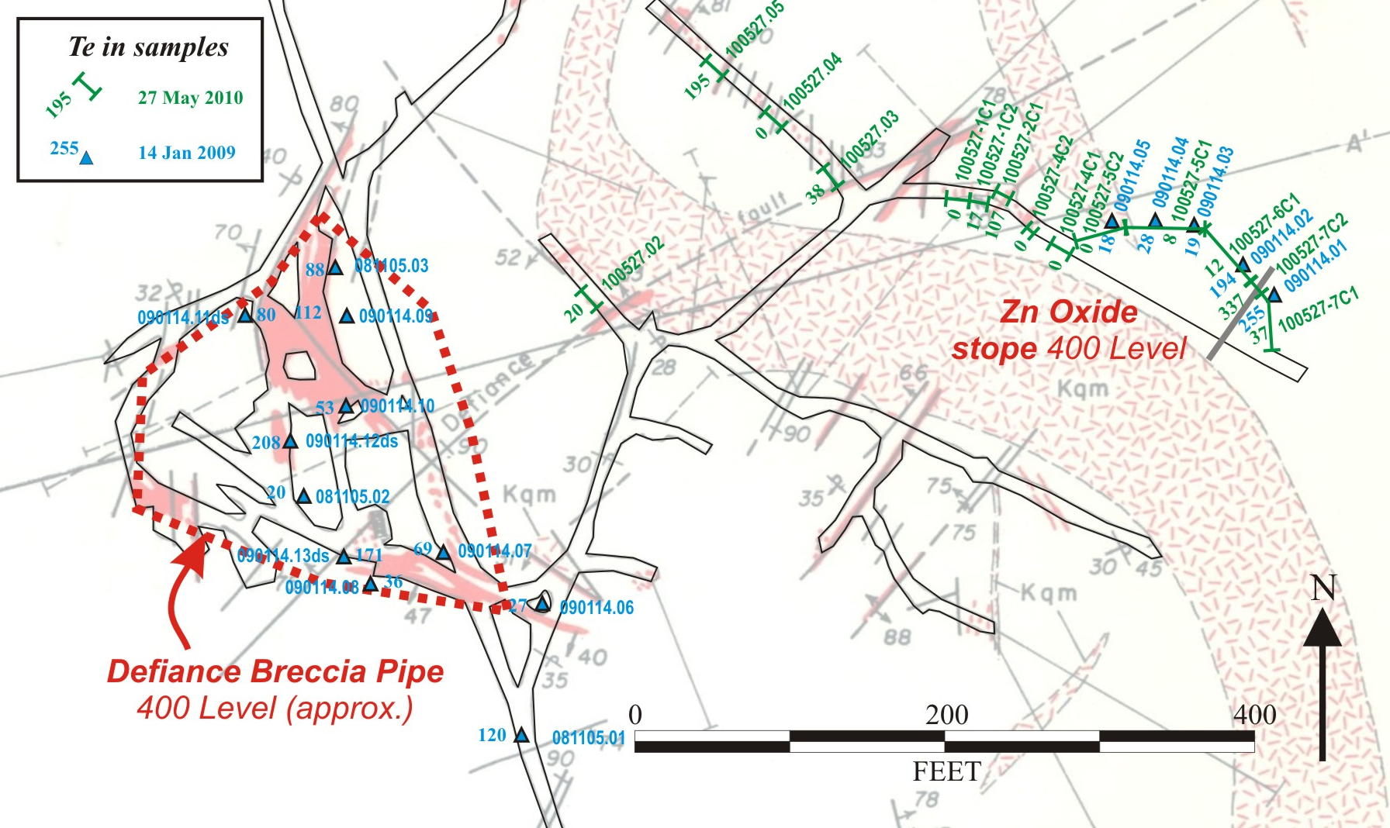
On 14 January 2009, I took 11 grab samples were taken in the Defiance Breccia area and another 5 samples were taken in the “Zn Oxide” stope on the 400 Portal Level at Darwin (Figure 1). The Defiance Breccia samples returned an average of 89 ppm Te and a high of 208 ppm Te. The Zn Oxide samples averaged 103 ppm Te with a high of 255 ppm Te. These 16 samples were analyzed by Florin Labs of Reno and formed the basis of WIM’s initial positive Te evaluation of Darwin. Unfortunately, Florin Labs soon after was found to have overstated Te in numerous samples from a New Brunswick Mo porphyry. WIM stopped using Florin Labs as a result, and considered the Darwin assays as flawed.
Figure 1 - Te in vicinity of Darwin Breccia Pipe (see Fig 4.1 of 081231 report)
A year later, Jack Stone, Darwin’s owner, submitted three 5-gallon bucket samples to Florin Labs for Te, Ge, and Ag analysis. Jack said he collected these samples from the Zn Oxide stope after a Chinese sampling delegation had shown repeated interest. In mid-May 2010, Florin reported Jack’s three samples to average 329 mg/kg Te and range between 55 mg/kg Te and 757 mg/kg Te. These reported values were better than my previous samples of 14 January 2009. I immediately had Jack’s three pulps re-assayed by Inspectorate-IPL and the rejects sent to WIM for petrographic analysis. Inspectorate-IPL reported an average of 275 ppm Te and values of 18 ppm Te, 98 ppm Te, and 708 ppm Te. WIM’s petrographer identified Te in Bi sulfides (24 June conversation). The 2010 Florin and Inspectorate-IPL assays from the Zn Oxide stope correspond.
I returned to Darwin on May 27th to verify Jack’s resampling with 10 grab samples in the Zn Oxide stope (100527-1C1to 7C1) and 4 grab samples (100527.02 to .05) in workings immediately west (Figure 1). I also reviewed Jack’s intentions for a pilot metallurgical facility and a mill should his Darwin Project go forward. The Chalfant mill is 10 miles north of Bishop, maintained and guarded, and currently set up for making a gold concentrate from sulfide ore at 50 tpd, upgradeable to perhaps 100 tpd. An oxide ZnAgTe ore would require addition of an acid vat leach circuit. My report on the pilot and mill facilities is forthcoming.
The results of the May 27th assays were received from Inspectorate-IPL on June 26th. The 10 grab samples in the Zn Oxide stope (100527-1C1to 7C1) average 195 ppm Te and range between nil Te and 337 ppb Te. The 4 grab samples (100527.02 to .05) in workings immediately west of the Zn Oxide stope average 63 ppm Te and range between 20 ppm Te and 195 ppm Te.
The samples taken in 2010 at Darwin suggest the 2009 assays may not be as suspect as we once thought. The 2009 and 2010 assays in the Zn Oxide stope show excellent correspondence with spatial and geologic characteristics. The 194 and 255 ppm Te assays from 2009 correspond spatially with the 337 ppm Te assay from 2010. The correspondence appears due to a mineralized, NE-striking, down-to-SE near-vertical fault (gray NE line in Figure 1) similar to several associated with the Defiance Breccia Pipe.
All of the WIM samples taken to date at Darwin are high-graded grab samples or isolated vertical channel samples from the 400 Level to verify the presence of Te. Plotted locations are approximate and relative to workings mapped in the late 1970’s. The Zn Oxide stope does not show up on these earlier maps. Samples from the Zn Oxide stope and adjacent area are all taken from strongly oxidized rock with occasional remnant sulfides.
The Te assay results and observed geologic relationships in the Zn Oxide stope suggest Te-mineralized, steep NE faults are similar to others nearby that are mapped as co-genetic with the Defiance Breccia Pipe. The “spottiness” of the 400 Level Te values may also be due to Te-destructive oxidation, and perhaps remnant bismuth sulfides retain Te better under oxidizing conditions. The implication: The unmined, unoxidized portions of the Defiance Breccia Pipe at depth (below 1,000 Level?) may be a significant source of byproduct Te, as well as economic Ag-Zn-In-Au. These physical and geochemical relationships should be clarified once Pete Hahn concludes his data and map compilation started this past week for Jack Stone.
Pete Hahn says Rob Wetzel, a former Blue Range employee working for Lithic Resources, has recently found high indium numbers on the 400 Level. Pete thinks the deep Zn-In-Te skarn target at Darwin is a good shot, with the Zn/Pb increasing with depth. He expects better skarn ores cored by quartz porphyries are later and west of the main Darwin stock. These later quartz porphyries are also apparently responsible for the Te-bearing Defiance Breccia. Pete has also promised me to keep me fully informed as his own work progresses.
Concerning sampling logistics, Pete hopes to gain working access to the deeper levels of the Defiance Breccia Pipe during the field phase of his compilation work (later July?). A WIM sampling team should join him when he accesses these deeper levels.

